This material has been moved to the Graduate School Homepage FAQ - Dissertation Specification Guide.

Please refer to the “standard method for preparing papers” according to the regulations of the graduate school policy.

- Types of Thesis
- Review Paper
(1) Guideline for submission
A thesis submitted to the chairperson and judges for evaluation, it should be submitted by temporary binding.
A thesis must provide to judges by non-examiner. To the judges, submit them through the college support department of their college.

(2) Review Paper writing guidelines
1) In principle, it should be written in Korean, but it can be written in foreign language with the approval of the advisor.
2) There is no limit to the amount of papers.
3) As a rule, the paper is made of white paper and the size is 4 · 6 sheet (about 257 × 188 mm).
4) It should be written in Word Processor.
5) Abstract should be placed in front of the table of contents within 2000 characters.
6) In the case of a doctoral dissertation, the abstract should be written in a foreign language. In the case of a foreign language, a Korean translation and a Korean translation should be submitted. However, this may be excluded if it is inevitable due to the nature of the foreign language literature and the related academic field.

- Finished Paper(Book binder)
1) If the thesis is passed through the examination, please upload the original version and the abstract of the thesis to the library homepage before submitting the completed thesis and the copyright consent.
2) Copy of thesis means that the same contents as those submitted online are printed / bound according to the form stipulated by the graduate school, and a certain number of copies are submitted to the designated library within a specified time.
3) Original version of thesis should be binded by hard-coded (Hard cover with black color) and approved by judges(chairperson). It should be keep by personally.
4) Three of the master's dissertations (medical professions in the fourth part) shall be hard-coded, and the remainder (except medical profession) shall be soft coded (white or gray soft cover)
5) All doctoral dissertations should be hard cover and gold-leaf print. The standard of this paper is 4 · 6 plates, and the lipid is 80 pounds. Completion of the cover of this thesis, etc. and preparation of the thesis according to the attached thesis writing standard.
6) After submitting dissertations to the library, submit one copy of the dissertation submission, abstract, and copy of the thesis (title page + examination completed page) to the each department’s administrative office.
(2) Writing guidelines
1) In principle, it should be written in Korean, but it can be written in foreign language with the approval of the advisor.
2) If the dissertation is written in a foreign language, it must be accompanied by a translation in Korean. However, in case of inevitable reason of foreign language literature and related scholarship, it may not be attached.
3) If the dissertation is written in a foreign language, it must be accompanied abstract by a translation in Korean.
4) For the order of dissertation form, please refer to the enclosed <학위논문 작성 규격>.

<학위논문 작성 규격>
- It should be accompanied [별지서식 3] or [별지서식 4] in thesis cover.
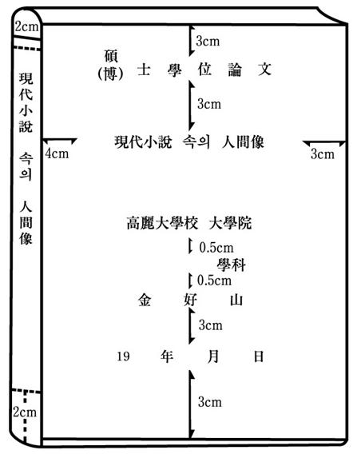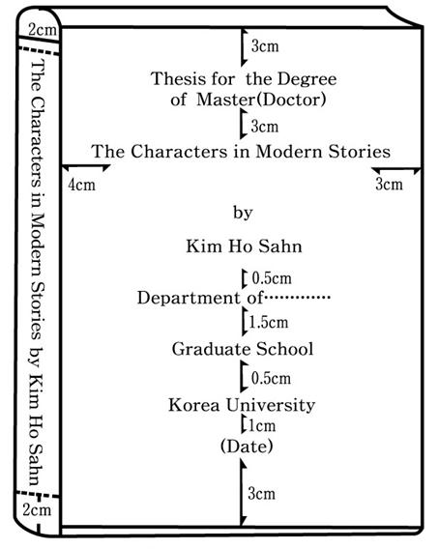
1) The size of the title should be 30 points when the number of characters is less than
10 characters, 28 points if it is less than 1 line, and 21 points if more than 2 lines
2) The name of the school (Graduate School, Korea Univ., Etc.) shall be 20 points when the
title size of the paper title is 28 points or more, and 18 points when it is 21 points
3) The Year, month, day and 인 shall be 14 points.
4) All other parts should be 16 points (department, name, advisor, master's thesis, ... submitted, completed, etc.).
5) Position the word follow as shown, but the others would be positioned as center.

- Insert a white sheet of paper after the cover sheet, and the title page of [별지서식 5] to the next sheet.
[별지서식 5]
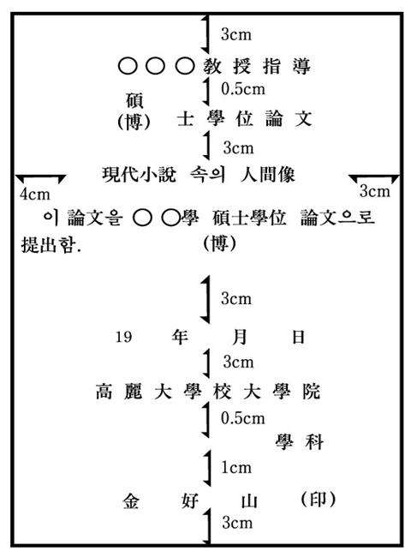

- In the next chapter of the title page, the completed inspection certificate of [별지서식 6] comes. Only two copies of the certificate (three copies of the medical department) are printed.

[별지서식 6]

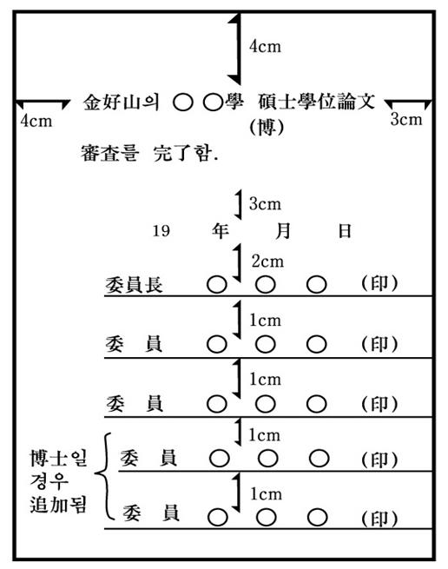

- In the next chapter of the completed inspection certificate, the table of contents [별지서식 7] comes.
[별지서식 7]
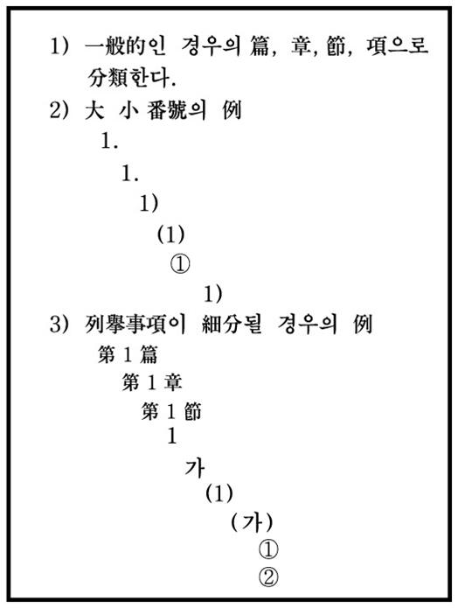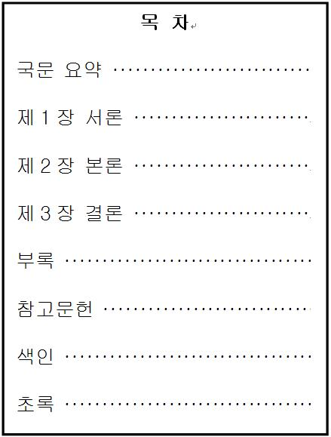

- After the table of contents, a white sheet is inserted again, and the text starts with the main text like [별지서식 8], and the text consists of the introduction, the main text, and the conclusion.
[별지서식 8]
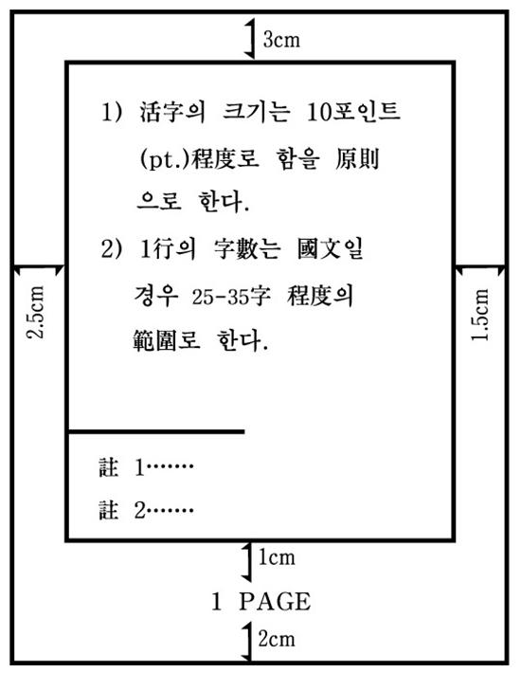

- When the text is over, insert a white cover and attach a reference. References should be in the order of appendices, references, and indexes.
- Attach abstract in foreign language like [별지서식 9].(only for required)
if thesis is written in foreign lanugage, provide abstract in korean, if thesis is written in korean, provide abstract in english.

[별지서식 9]

